Whitney Woelmer, Master’s Prospectus Outline

**Overall Introduction**

1. Importance of freshwater ecosystems and the many services they provide (setting up why their water quality is so important, as well as what services are the highest priority- e.g., clean water for drinking, etc.)
2. Threats to freshwater systems in a changing world have been increasing the occurrence and severity of eutrophication in freshwaters
   1. Watershed effects which cascade down to freshwater systems
      1. Land use shifts can lead to quicker deliver of nutrients to water bodies and increases in the amount of nutrients water bodies receive
      2. Increasing human population also leads to increases in nutrients through human waste and urban pollution, which negatively impact water quality
      3. Nutrient effects cause rapid changes in phytoplankton populations, understanding how nutrients are processed within a reservoir will help to forecast phytoplankton. By studying nutrient and phytoplankton dynamics at a high-resolution spatial scale, we can gain an understanding of chemical and biological hotspots of activity and further identify areas of greater risk of eutrophication under a changing climate.
   2. Further, global climate change in unpredictable, meaning we don’t know exactly what pressures will effect freshwater systems
3. Research to understand how systems are currently changing and developing efforts to anticipate their future response is more important than ever
   1. to allow society to coexist with changing ecosystems
   2. for managers to preemptively manage/anticipate impending poor water quality events
   3. Lake Erie 2014 example, major social and economic loss

**Proposed Research**

*Chapter 1: Developing near-term forecasts of phytoplankton in a drinking water reservoir***Introduction**

As our world continues through an era of change and human populations continue to grow, understanding not only the current state of our freshwater ecosystems, but predicting how they will respond tomorrow, next week, and next year is of utmost importance. The current shift in the scientific community towards publishing data in publicly accessible venues, as well as the development of high-frequency sensors which result in massive amounts of data have both made it possible for the field of ecological forecasting to develop now. Therefore, the ability to forecast the future state of our drinking water sources is of utmost importance to society and freshwater ecology as a discipline.

Forecasting as a practice has been developing for decades in many disciplines and has substantial breadth. Uses of forecasting can be found in many fields and applications, ranging from the well-known and widely-used weather forecasts to epidemiological forecasts of population mortality (Lee and Carter, 1992) and global Alzheimer’s trends (Brookmyer et al 2007) to forecasts of bankruptcy declaration in the United States (Shumway et al 2001). Many of these fields have been priming their forecasting abilities for decades (Shumway et al 2001). For example, SENTENCE ABOUT HOW ADVANCED WEATHER FORECASTING IS AND THE TRIAL AND ERRORS GONE THROUGH—LOOK IN DIETZE. However, the development of forecasts specific to ecological systems and ecosystem services is still in its relative infancy (Dietze book YEAR).

While being an emerging field within forecasting, ecological forecasting currently spans numerous disciplines, with a variety of purposes. To better understand the current state of studies using ecological forecasting, we conducted a small literature review. Studies were found using the Google Scholar database and the search term ‘ecological forecasting.’ Studies which met the following requirements were selected as using ecological forecasting methods: 1) use models, 2) quantify uncertainty to make a probabilistic forecast, and 3) run the model outside a given training period (Table 1).

Because the field of ecological forecasting is relatively new, there is not yet a consensus as to the best approach for predicting water quality. Empirical methods are favored a majority of times (65%, n= 17, Table 1) of current forecasting studies selected. Empirical approaches are popular because of their data-driven character; they are inherently suited for a particular system because they are based on past trends within that system. Input data for empirical models are commonly available through routine monitoring of a system, and these models do not require specific input data, but can be developed using a variety of ecological important driver variables. Additionally, empirical models are relatively easy and quick to develop and implement. However, because empirical models are built on the historic conditions of a system, if future conditions are outside the realm of past conditions, models might no longer be able to capture the mechanism responsible for changes. In contrast, process-based models were favored in just over a third of the studies examined (n=17, Table 1). It is not surprising that process-based models are currently less frequently used in the ecological forecasting literature given the hefty amount of input data often required to run the model, as well as the amount of time and expertise required of both the system being modeled and the model itself in order to properly calibrate the multitude of parameters within the model. However, these models may be especially useful in the current era of global change given their ability to explain underlying mechanisms which cause a given response, and are likely more generalizable to other systems because they are based on a set of fundamental equations rather than the historical pattern of a system.

The studies examine in our literature study spanned the realm of basic and applied research, showing motivations to understand the current state of science or to apply a forecast product to better informing management. While a majority of the studies in our literature review were conducting basic scientific research (73%, n = 15 ), all of the studies touting applied intentions were focused on informing management of freshwater systems in particular. This illustrates not only the interest in the scientific community to understand changing freshwater systems, but the need by managers and stakeholders for probabilistic forecasts in order to cope with and adapt to changing freshwater system

|  |  |  |  |  |
| --- | --- | --- | --- | --- |
| Table 1. Summary of literature review targeting studies using ecological forecasting methods | | | | |
| Authors & Year | Best Model | Forecast Product | Use of forecast product (basic or applied) | Reference |
| Araujo et al. 2005 | Empirical | Bird species ranges | Basic |  |
| Araujo et al. 2006 | Empirical | Amphibian and reptile species distributions | Basic |  |
| Brown et al. 2013 | Process-based and empirical | Chesapeake Bay water quality | Applied |  |
| Dean et al. 2004 | Process-based | Carbon sequestration in forests | Basic |  |
| Estes et al. 2013 | Empirical | Productivity and suitability of crops in South Africa | Basic |  |
| Fenocci et al. 2019 | Process-based | Phytoplankton dynamics | Basic |  |
| Hazen et al. 2017 | Empirical | Blue whale density | Applied |  |
| Lindegren et al. 2013 | Process-based | Baltic cod dynamics | Basic |  |
| Liu et al. 2006 | Empirical | Coral Reef Bleaching | Applied |  |
| Martinez-Meyer et al. 2004 | Empirical | Ecological niches of mammal species | Basic |  |
| Perretti et al. 2013 | Empirical | Species abundance | Basic |  |
| Stow et al. 2003 | Process-based and empirical | Estuarine water quality | Applied |  |
| Thomas et al. 2018 | Empirical | Phytoplankton dynamics | Basic |  |
| Thuiller et al. 2004 | Empirical | Tree species distributions | Basic |  |
| White and Nemani 2004 | Process-based | Soil water | Basic |  |

My first chapter will focus on addressing the knowledge gap in ecological forecasting regarding how best to forecast water quality. I will produce hindcasts and near-term iterative forecasts of phytoplankton in a drinking water reservoir using both an empirical and a process-based approach. Model performance will be assessed by a suite of metrics addressing both the ability of the model to capture overall dynamics, as well as extreme events. My work will specifically address the following questions:

* + Question 1: How well can an empirical model and a process-based model hindcast observed chlorophyll dynamics?
  + Question 2: How well can an empirical model and a process-based model forecast near-term chlorophyll-a dynamics over a 16-day period (assessed through quantified uncertainties of a probabilistic forecast compared to observed dynamics)?
  + Question 3: What information does an ensemble model approach provide for chlorophyll forecasting that cannot be explained from a single-model approach?
* This Chapter 1 will thus span the field of applied and basic forecasting science by**: 1) informing managers and decision-makers about which variables are most important for routine monitoring and management of water quality in the face of land use and climate change, 2) providing essential information to the freshwater research community regarding modeling approaches to forecasting water quality, and 3) expanding the scientific field of ecological forecasting that will guide forecasting applications across many different ecosystems.**

**Methods**

*Study Site*

Falling Creek Reservoir (FCR) is a small (~12 ha), shallow (maximum depth < 9.3m) dimictic drinking water reservoir located in southwestern Virginia. FCR is owned and operated by the Western Virginia Water Authority (WVWA). The watershed of FCR is almost entirely forested, although the reservoir continues to exhibit incidences of poor water quality as a result of historical eutrophication of the reservoir (Gerling et al 2016). The major water source to FCR comes from a single tributary which flows from Beaverdam Reservoir (BVR; Figure 1).

Figure 1. Map of Falling Creek Reservoir and Beaverdam Reservoir and their watersheds

*Historical and sensor dataset*

An extensive, routine monitoring dataset of water quality in FCR has been collected since 2013 in collaboration with the WVWA and Virginia Tech. This dataset includes meteorological, physical, chemical, and biological data collected both at the deep hole of the reservoir and at the major inflow to FCR (add lots of lab citations here). The inflow dataset also includes discharge to the reservoir measured every 15 minutes at a weir installed at the stream site. More recently, as part of the Smart and Connected Communities (SCC) project, FCR has been outfitted with numerous high-frequency sensors to capture real-time changes in water quality. These data are streamed wirelessly to an online server and appended to the ongoing datafile. Sensor data includes meteorological, physical, chemical, and biological data.

*Model Development (Question 1)*

We will develop both an empirical and a process-based model to forecast chlorophyll-a in the surface water (1.0 m) at FCR during the summer stratified period (May-October) when phytoplankton populations are at their highest. The training period for both models will be 2013-2016 during which we have regularly, weekly coverage of both response and driver data. Both models will be validated using data from 2018.

Empirical: ARIMA

We chose an autoregressive integrated moving average (ARIMA) generalized linear model for our empirical approach to forecasting chlorophyll-a in FCR. The appropriate time step to be included as the autoregressive term in ARIMA will be determined by selecting the previous measurement of chlorophyll-a with the highest Pearson’s r correlation coefficient with the current measurement of chlorophyll-a. From a pool of 53 meteorological, physical, chemical, and biological driver variables, we will select only driver variables which are predictable in nature (e.g., meteorological and inflow variables). From within the pool of predictable driver variables, we will further select only variables which are not correlated with each other through the use of a Pearson’s correlation analysis. Using these variables, we will develop all possible ARIMA combinations with the selected driver variables, and the best model will be determined by AICc (Akaike’s Information Criterion) and parsimony.

Process-based: GLM

We used the General Lake Model, Aquatic Ecodynamics (GLM-AED) as our process-based model. GLM-AED is a one-dimensional hydrodynamic model, etc.

Model Assessment

Model performance will be assessed using a number of metrics currently being used in the ecological forecasting field. Because there is no one metric which can determine that one model performs better than another, a holistic approach examining several model performance metrics will be used instead.

Comparisons of observed and model descriptors will include the mean, standard deviation, quantiles (Dietze book), and kurtosis (Bennett et al 2013). Forecasts are said to be in consensus if they are insignificantly different from the sample mean (Gregory et al ., 2001)

Model outputs will also be compared with each other using the following performance metrics:

* RMSE
* R2 (variation from the 1:1 line)
* Bias
  + SD(model)/SD(data)
  + Base R bias calc mean(observed – model)
* Slope of the regression btw model and OBS
* Pearson’s correlation between the model and OBS
* Area under the curve (Araujo, Thuiller, and Pearson 2006)

Lastly, model performance will be examined through visual assessment of the following figures (Dietze book):

* Observed and model predictions over time
* Predicted vs. observed + 95% confidence interval

*Forecasting Framework: FLARE (Question 2)*

Both models will be integrated into an existing forecasting framework, Forecasting Lake and Reservoir Ecosystems (FLARE), to produce iterative near-term 16-day forecasts of chlorophyll-a. FLARE is designed to pull 2-week weather predictions from the National Oceanic and Atmospheric Administration (NOAA) to force both ARIMA and GLM-AED. Additionally, ARIMA’s autoregressive term will be forced using our established sensor-cloud network to provide yesterday’s chlorophyll-a concentration. Lastly, inflow discharge data for both models will be estimated using an autoregressive linear model of discharge based on the previous day’s mean discharge at the major inflow to the reservoir. Driver uncertainty will be calculated for both ARIMA and GLM-AED forecasts by propagating the uncertainty associated with the NOAA weather forecasts. Parameter uncertainties for both ARIMA and GLM-AED will be calculated by sampling from a distribution of parameters within each model. Forecast effectiveness will be assessed using a suite of performance metrics calculated by comparing the forecast model outputs to the observed high-frequency chlorophyll-a sensor in FCR. Assessment metrics will be calculated for various conditions (summer stratified period, fall mixed period, winter ice period, and following storm events) to determine which approach is most robust under different conditions.

*Integrated Model Averaging (Question 3)*

In order to develop the most informative forecast of chlorophyll-a, we will develop a weighted model including both empirical and process-based model outputs average to incorporate the strengths of multiple models. This will allow the forecast to capture as much variability as possible in chlorophyll-a if for example, one model does a better job of prediction chlorophyll-a at lower concentrations, while another model is more effective at capturing large bloom events. Particularly for low probability yet high impact events such as large blooms in phytoplankton, preliminary results show that a third model may be necessary to capture these peaks in phytoplankton concentration that may operate under different mechanisms. Incorporating multiple models will enable us to develop an early-warning system which will alert users when conditions that indicate a peak in phytoplankton is likely to occur.

**Preliminary Results**

Hindcasts of chlorophyll-a

Using the summer period of 2013-2017 as our training period, we developed and calibrated both an empirical, ARIMA, and process-based model, GLM-AED. Our best-fitting ARIMA model over 2013-2016 included discharge to the reservoir and shortwave radiation. ARIMA hindcasted chlorophyll-a over 2013-2016 with an R2 = 0.44 and RMSE = 1.71 ug/L. The ARIMA model was able to successfully capture fluctuations at lower chlorophyll-a concentrations (<10 ug/L) (Figure 2). However, when chlorophyll-a reached values above ~10 ug/L, the model the model was unable to recreate these observed dynamics. GLM-AED was calibrated over 2013-2016 and hindcasted chlorophyll-a with R2 = XXX and RMSE = YYYY. While GLM-AED does not capture as much detail in chlorophyll-a dynamics, it does capture some large peaks in chlorophyll-a that ARIMA does not. 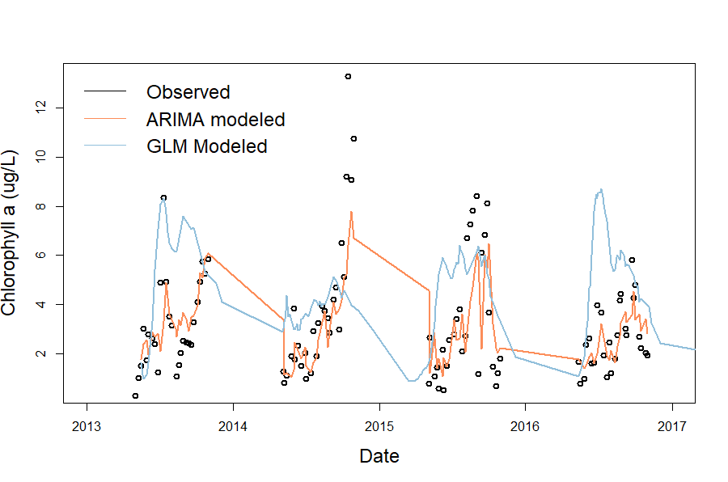

Figure 2. Observed and modeled chlorophyll-a data over 2013-2016.

|  |  |  |  |  |  |
| --- | --- | --- | --- | --- | --- |
| **Table 2. Proposed timeline for Chapter 1** *Black boxes indicate completed tasks, gray boxes indicate proposed completion* | | | | | |
|  | Fall 2018 | Spring 2019 | Summer 2019 | Fall 2019 | Spring 2020 |
| Develop ARIMA GLM-AED |  |  |  |  |  |
| Calibrate GLM-AED |  |  |  |  |  |
| Produce hindcasts |  |  |  |  |  |
| Validate model (Q1) |  |  |  |  |  |
| Adapt FLARE code for ARIMA (Q2) |  |  |  |  |  |
| Create integrated model average (Q3) |  |  |  |  |  |
| Run forecasts in FLARE |  |  |  |  |  |
| Submit manuscript, *target journal: Ecological Applications* |  |  |  |  |  |

**Chapter 2. Spatial heterogeneity of nutrients and phytoplankton along a double reservoir continuum**

In the face of global change, understanding how and why freshwater systems vary is more important than ever. Identifying ‘hotspots’ of chemical or biological activity can help prioritize management efforts to areas within freshwater systems that are more vulnerable to eutrophication or changes in trophic status. These hotspots are inherently connected to the incoming chemical or biological activity from upstream water sources. Varying types of freshwater systems, for example streams and lakes, each have unique ways of retaining and transporting nutrients and biota, meaning accounting for the presence of these waterbodies upstream is crucial to understanding what nutrients are being received downstream by a waterbody. For example, Kling et al. (2000) found that the amount of consumption or production of nutrients which occurred within a lentic system was approximately reciprocated within subsequent lotic systems. However, this study is somewhat unique in focusing on both lentic or lotic systems, while most do not consider how these systems relate to one another.

Reservoirs specifically are systems marked by physical heterogeneity and are classically defined as having a gradient of riverine, transitional, and lacustrine zones (Thornton et al. 1990). The chemical and biological communities along this reservoir gradient are often discrete between zones as well, showing a high amount of heterogeneity as you go along the downstream gradient of the reservoir. We know that many processes which consume or produce nutrients occur within waterbodies such that nutrients going into a system are substantially different from those going out (Harrison et al. 2009, Kling et al. 2000, Powers et al. 2015, for example). However, studies examining how concentrations of nitrogen, phosphorus, and chlorophyll-a within reservoirs change along the reservoir gradient report inconsistent patterns. Some have found that nitrogen is highest in the riverine zone due to high nutrient inputs from the watershed (Soares et al. 2012), while others have found that the transitional zone, where turbulence is decreased yet nutrients are still abundant, is a hotspot for nitrogen concentrations (Scott et al. 2009). Similarly, patterns in chlorophyll-a heterogeneity are inconsistent between studies, with some studies finding that chlorophyll-a is highest in the riverine zone, decreasing along the downstream gradient (Scott et al. 2009). In contrast, others report the transitional zone as being a hotspot for phytoplankton activity (Rychtecky & Znachor, 2011), and others still have found the lacustrine zone to be rich in chlorophyll-a in systems that are not limited by nutrient availability (Soares et al. 2012). Further, Borges et al. 2008 found that the longitudinal pattern of heterogeneity of chlorophyll-a was variable with season in two tropical reservoirs in Brazil. Trends in phosphorus heterogeneity are less often reported. One study of a large, deep reservoir in the Czech Republic showed that both soluble and total phosphorus decreased along the reservoir gradient (Rychtecky & Znachor, 2011). Borges et al. (2008) found contrasting patterns in two reservoirs in Brazil, one showing a decrease in phosphorus along the reservoir gradient, while another showed no clear longitudinal pattern. While all of these studies agree that spatial heterogeneity of nutrients and phytoplankton exists along a reservoir gradient, a clear pattern does not arise across reservoir type, and a lack of research on small, eutrophic reservoirs is apparent. A better understanding of the heterogeneity of a variety of reservoir types is crucial to identifying hotspots of chemical and biological activity.

An important factor that can affect the heterogeneity of chemical and biological variables is hydrologic flow. Under low flow conditions, residence times of reservoirs and streams are increased, resulting in slower export of nutrients and more time for biotic processing (Saunders and Kalff, 2001). However, high flow conditions can also bring in large amount of external nutrients which are often limiting to phytoplankton. Retention time directly affected spatial heterogeneity in a tropical reservoir (Soares et al 2012), with longer retention times showing greater spatial heterogeneity, as the riverine, transitional, and lacustrine zones become more physically distinct. Further, preliminary results from forecasting phytoplankton in my study system has revealed the importance of stream discharge, or changes in hydrologic flow, to phytoplankton dynamics at the deepest site of a reservoir. This findings highlights the need to better understand the importance of hydrologic flow to phytoplankton along the entire reservoir gradient. While forecasting is a necessary first step in anticipating these changes, more work needs to be done to better understand these systems and decrease the uncertainty in our forecasts.

Lastly, a major driver of differences in chemical and biological composition of a waterbody is the presence of upstream waterbodies. Studies looking at the effect of watershed connectivity and lake chain show that downstream nutrients are significantly reduced by the presence of impoundments upstream (Bosch et al. 2009, Powers et al. 2015, Stachelek & Soranno 2019). In contrast, Brown et al. (2008) found that increases in upstream lake area was significantly correlated to increases in total nitrogen of small mountain lakes. Studies looking at lake chain impact are not usually associated with a high-resolution spatial coverage of connecting streams or with high-resolution spatial coverage within the lakes or reservoirs. How does reservoir chain location influence spatial heterogeneity?

**Proposed Work**

My second chapter will focus on the longitudinal spatial heterogeneity of nitrogen, phosphorus, and chlorophyll-a in Beaverdam Reservoir (BVR) and Falling Creek Reservoir (FCR) and the influence of reservoir chain number on this heterogeneity. Additionally, I will examine the impact of seasonality and hydrologic flow on heterogeneity. This research will ultimately better inform our understanding of how freshwater systems, both lentic and lotic, will respond in the face of global climate change, which is expected to include more variability in residence time as a result of changing precipitation patterns.

***Question 1****: What is the longitudinal heterogeneity of nitrogen, phosphorus, and chlorophyll-a along a double reservoir continuum?*

**Hypothesis 1**: I hypothesize that there will be spatial heterogeneity in nitrogen, phosphorus, and chlorophyll-a within the both BVR and FCR along a reservoir gradient of riverine to transitional to lacustrine (Figure 3). While some studies posit that chemical and biological activity should be lowest in the lacustrine zone due to nutrient limitation (Kimmel et al. 1990), I believe this will not be the case in our shallow, eutrophic reservoirs which experience substantial internal loading (Gerling et al. 2016).

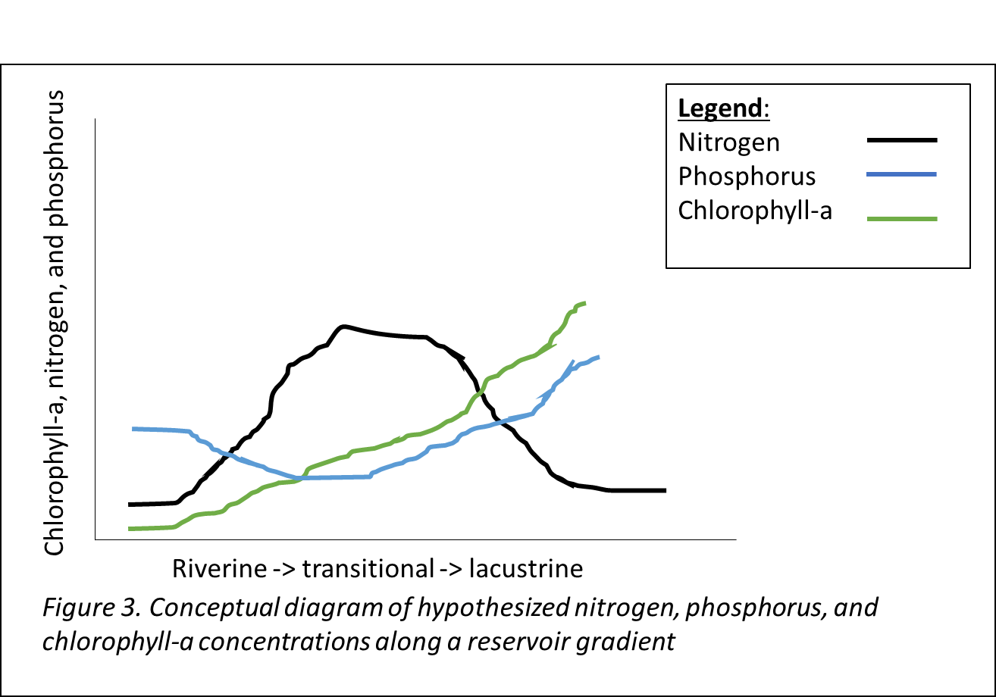

***Question 2****: How does a gradient of hydrologic flow conditions influence longitudinal heterogeneity?*

**Hypothesis 2:** I hypothesize that increases in flow will increase spatial heterogeneity in both reservoirs (Figure 4).

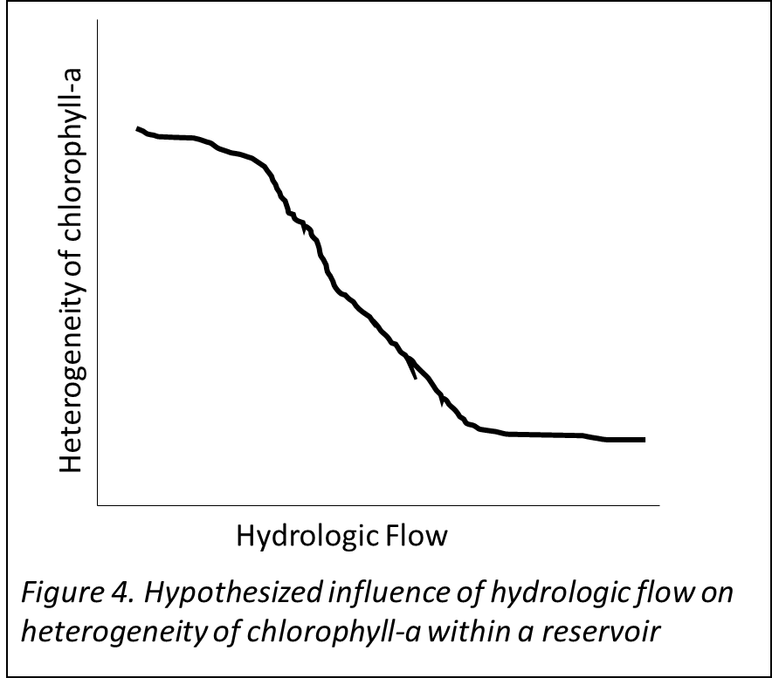

***Question 3****: Does the presence of an upstream reservoir influence the relative concentration of phytoplankton in a downstream reservoir?*

**Hypothesis 3**: I hypothesize that the relative concentration of nitrogen will increase with reservoir chain number, and the relative concentrations of phosphorus and chlorophyll-a will decrease with reservoir chain number (Figure 5).

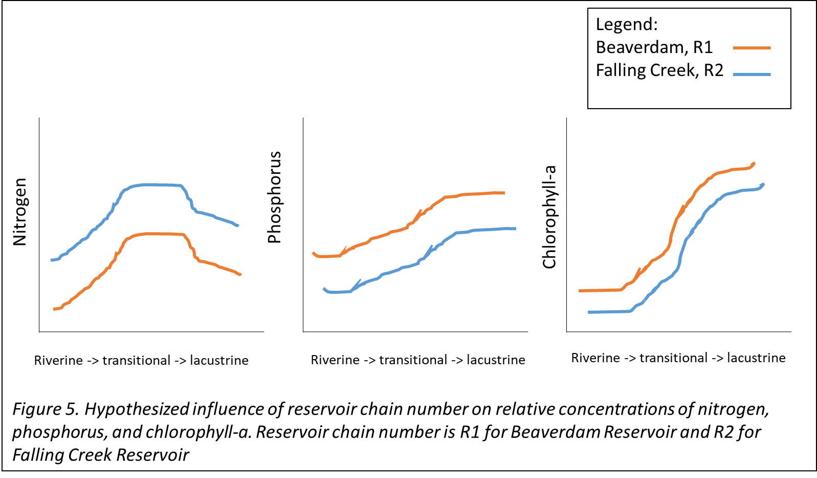

**Methods**

*Study site*

Beaverdam Reservoir (BVR) is a small (39 ha), shallow (maximum depth < 13m), dimictic reservoir owned and operated by the Western Virginia Water Authority (WVWA) and located in Vinton, VA. BVR has multiple inflow streams, but we have selected the major inflow in the western and the eastern arms for this study (Figure 1, above). BVR has an outflow pipe that flows to Falling Creek Reservoir (FCR), a smaller (), shallower (), dimictic reservoir, also owned and operated by WVWA.

*Field sampling, summer 2019*

We intend to sample once per month from May to September to capture a gradient in seasonal conditions. Additionally, we will add adaptive sampling events to capture a gradient of hydrologic flow conditions (n = ~8).

* Sites
  + The major stream inflow to the western and eastern arms of BVR (n = 2)
  + 4 sites within BVR to capture a gradient of riverine, transitional, and lacustrine conditions, as well as the outflow pipe to FCR
  + 4 sites along BVR-FCR inflow stream
  + 5 sites within FCR to capture a gradient of riverine, transitional, and lacustrine conditions
  + FCR outflow
* Data collection
  + Nutrient chemistry (total and soluble nitrogen & phosphorus)
  + Discharge at stream sites (using a flowmeter)
  + Physical characteristics from YSI (dissolved oxygen, conductivity, temperature)
  + Chlorophyll-a
* Sampling frequency

*Data analysis*

* + Correlation analysis to determine level of synchrony between FCR and BVR
  + Generalized linear models to analyze drivers of nutrient and phytoplankton dynamics along a stream-reservoir gradient

CITATIONS (Incomplete)

Thornton, K. W., B. L. Kimmel & F. E. Payne (eds), 1990. Reservoir limnology: ecological perspectives. Wiley, New York.